

**Hygeia E-HealthCare System**

***A Project Report submitted in partial fulfillment of the requirements for the award of the degree of***

# Bachelor of Computer Applications

## By

|  |  |
| --- | --- |
| **Mr. Aakash Singh** | **(184200001)** |
| **Mr. Rahul Sharma** | **(184200123)** |
| **Mr. Shubham K. Patel** | **(184200159)** |
| **Mr. Shiva Singh** | **(184200153)** |
| **Mr. Devendra Jangid** | **(184200054)** |
| **Mr. Lokesh Singh** | **(184200092)** |

Under the Guidance of

**Mr. Gaurav Sharma**

**(Assistant Professor)**

Department of Computer Engineering & Applications

**Institute of Engineering & Technology**

|  |
| --- |
|  |

**GLA University**

**Mathura- 281406, INDIA**

**February , 2020**

**Department of Computer Engineering and Applications GLA University, Mathura**

**17 km. Stone NH#2, Mathura-Delhi Road,**

**P.O. – Chaumuhan, Mathura – 281406**

**U.P (India)**

**Declaration**

We hereby declare that the work which is being presented in the B.C.A. Project **“Hygeia E-HealthCare System”**, in partial fulfillment of the requirements for the award of the ***Bachelor of Computer Applications*** and submitted to the Department of Computer Engineering and Applications of GLA University, Mathura, is an authentic record of our own work carried under the supervision of **Mr. Gaurav Sharma, (Assistant Professor of Computer Engineering Department).**

The contents of this project report, in full or in parts, have not been submitted to any other institute or university for the award of any degree.

|  |  |
| --- | --- |
| **Mr. Aakash Singh** | **(184200001)** |
| **Mr. Rahul Sharma** | **(184200123)** |
| **Mr. Shubham K. Patel** | **(184200159)** |
| **Mr. Shiva Singh** | **(184200153)** |
| **Mr. Devendra Jangid** | **(184200054)** |
| **Mr. Lokesh Singh** | **(184200092)** |

**Abstract**

As a global pandemic is upon us hospitals are the busiest, they’ve ever been throughout the history of mankind for the first time and hence it is very difficult for them to overlook and utilize all the resources, staff, occupants and etc. which leads to a waste of precious time

To Improvise this experience Hygiea E-Health care system provides one stop solution for administrator, public and doctors. Now admin can have a birds-eye view over hospital resources and human resources and use them in a efficient and effective way, Doctor can also keep a track of their patients and their health with a wide number of helpful features. Patients can also benefit from this system as all their reports are stored on a server and they can view them anytime they want also they can directly schedule appointments for the doctors they want to see.

In this approach we go beyond approaches that rely on textual and conceptual similarities and we propose a robust approach that leverages a health care management system, we experimentally study the performance of different techniques, and showcase their potential, especially when combined together.

**CONTENTS**

|  |  |
| --- | --- |
| **Topic**  Certificate Acknowledgement | **Pg.no.**  I  II |
| Chapter1 Introduction | 1 |
| 1.1 Overview &Motivation | 1 |
| 1.2 Organization of Project Report | 2 |
| Chapter2 Software Requirement Analysis | 3 |
| 2.1 Requirement Analysis | 3 |
| 2.1.1 Hardware Requirement | 4 |
| 2.1.2 Software Requirement | 4 |
| 2.1.3 Tools and Technologies | 4 |
| 2.2 Feasibility Study | 5 |
| 2.2.1 Technical Feasibility | 5 |
| 2.2.2 Operational Feasibility | 6 |
| 2.2.3 Economical Feasibility | 7 |
| 2.3 Analysis | 7 |
| 2.4 Summary of Modules | 8 |
| Chapter3 Software Design | 9 |
| 3.1 DFD | 10 |
| DFD Level 0 | 11 |
| DFD Level 1 | 11 |
| 3.2 ER | 12 |
| ER Diagram | 13 |
| 3.3 Database Design | 14 |
| Chapter 4 Implementation & User Interface | 18 |

|  |  |
| --- | --- |
| Chapter 5 Software Testing | 26 |
| 5.1 Testing | 26 |
| 5.2 Objectives of Software Testing | 26 |
| 5.3 Principles of Software Testing | 27 |
| 5.3.1 White Box Testing | 27 |
| 5.3.2 Black Box Testing | 27 |
| 5.4 Testing Fundamentals | 28 |
| 5.5 Testing Information | 28 |
| Conclusion | 29 |
| References | 30 |

**Certificate**

This is to certify that the above statements made by the candidates are correct to the best of my/our knowledge and belief.

#### Project Supervisor Date:

**(Mr. Gaurav Sharma)**

Project In charge Program Coordinator Head of Department

**(Mr. D.P Yadav) (Mr. Narendra Mohan) (Prof. Anand Singh Jalal)**

**ACKNOWLEDGEMENT**

The satisfaction which accompanies the successful completion of the project, is incomplete without the mention of a few names. We take this opportunity to acknowledge the efforts of the many individuals who helped us to make this project possible.

Firstly, we would like to express our heartfelt appreciation and gratitude to our project guide **Mr. Gaurav Sharma, (Assistant Professor), Computer Engineering Department.** His vision and execution aimed at creating a structure, definition and realism around the project and fostered the ideal environment for us to learn and do. This project is a result of he’s teaching, encouragement and inputs in the numerous meetings he had with us, despite his busy schedule.

We would also like to extend our immense gratitude to respected Head of Department **Prof. Anand Singh Jalal** who allowed us to choose the topic for our dissertation.

The experience was novel one and we would like to thank all the people, who have lent their valuable time for the completion of the report. Without their consideration it would have been difficult to complete the report.

Chapter 1 **Introduction**

## Present Problem Statement:

* Integration of Corporate Medicare centers is very difficult while it is having different branches.
* It is very difficult to analyze the usage percentage of hospital resources, Bed occupation Ratio, Administration, Laboratory information even in a single center. Then we can expect the complexity while integrating multi-specialty Medicare Centers.
* Lack of generic and unique model we have to implement the same set of data model for every newly established Medicare Center.

## Proposed System:

## To optimize bed occupation.

## To improve the use of operating theatres, avoiding the cancellation of operations.

## To optimize the allocation of human and material resources to wards and shifts.

## There are three modules in this project:

## Administration

## Doctor

## Client

* 1. **Overview and Motivation:**

## Overview:

## The main objective of our project is to provide a reliable, robust and transparent system for hospitals that can be used by administration, doctors and patients to access different services offered by our system.

## Motivation:

* Optimal usage of resources, staff and services
* Saving time and money that’s wasted otherwise
* Providing a reliable system for everyone

## Organization of Project Report:

|  |  |
| --- | --- |
| **PHASES** | **TIME DURATION** |
| Software requirement specification | 1 weeks |
| System design | 3 weeks |
| Coding | 6 weeks |
| Testing | 2 weeks |
| Documentation | 1 weeks |
| Implementation | 1 weeks |

Chapter 2 **Software Requirement Analysis**

System Analysis is a detailed study of the various operations performed by a system and their relationship within and outside the system. It is a systematic technique that defines goals and objectives the goal of the development is to deliver the system in the line with the user’s requirements, and analysis is this process.

System study has been conducted with the following objectives in mind: -

* + - Identify the client’s need.
    - Evaluate the system concept for feasibility.
    - Perform economical and technical analysis.
    - Allocate functional to hardware, software, people, database and other system elements
    - Establish cost and schedule constraints.
    - Both hardware and software expertise are required to successfully attain the objectives.
    - To minimize the resources used and to maximize the efficiency.

## Requirement Analysis

Information gathering is usually the first phase of the software development project. The purpose of this phase is to identify and document the exact requirements for the system. The user’s request identifies the need for a new information system and on investigation re-defined the new problem to be based on MIS, which supports management. The objective is to determine whether the request is valid and feasible before a recommendation is made to build a new or existing manual system continue

The major steps are –

* + - Defining the user requirements.
    - Studying the present system to verify the problem.
    - Defining the performance expected by the candidate to use requirement.

#### **Hardware Requirements**

Processor : Intel Dual Core or More Processor Speed : 1.5 GHZ

RAM : 2 GB

Hard Disk : 20 GB of free space

#### **Software Requirements**

**Operating System** : Windows 7 and higher

**Front End** : HTML, CSS, Java Script, Bootstrap

**Back End** : SQL Server, PHP, JavaScript

#### **Tools and Technology** **Tools:**

* + - * Windows 7 & and higher
      * Notepad++ and Sublime Text
      * XAMPP
      * SQL Server

#### **Technology:**

* **SQL** is a structured query language used for querying database.
* **CSS:** CSS is cascading style sheet which is used to give designer look to HTML using the external file.
* **PHP:** Hypertext Preprocessor is a server-side scripting language designed for web development but also used as a general-purpose programming language.
* **Java Script:** Java Script is a dynamic computer programming language. It is lightweight and most commonly used as a part of web pages, whose implementations allow to make dynamic pages.
* **HTML:** Hypertext Markup Language is the standard markup language for creating web pages and web application. HTML element are the building blocks of HTML pages. With HTML constructs, image and other objects, such as interactive form.
* **Bootstrap:** BootStrap is a free and open-source CSS framework directed at responsive, front-end web development. It contains CSS- and JavaScript-based design templates for typography, forms, buttons, navigation, and other interface components

## Feasibility Study

Feasibility study is the process of determination of whether or not a project is worth doing. Feasibility studies are undertaken within tight time constraints and normally culminate in a written and oral feasibility report. We have taken fixed time in feasibility study with developers. The contents and recommendations of this feasibility study helped us as a sound basis for deciding how to precede the project. It helped in taking decisions such as which software to use, hardware combinations.

#### **Technical feasibility:**

This is concerned with specifying equipment of software and hardware that will successfully satisfy the user requirements. The technical needs of the system may vary considerably, but might include:

* The facility to produce output in a given time.
* Response time under certain condition.
* In examining technical feasibility, configuration of the system is given more importance than the actual makes of hardware. The configuration should give the complete picture about the system requirements. What speeds of input and output should be achieved at particular quality of printing.

According to the definition of technical feasibility the compatibility between front-end and back-end is very important. In our project the compatibility of both is very good. The degree of compatibility of PHP,JavaScript and MY SQL Server 2018 is very good. The speed of output is very good when we enter the data and click button then the response time is very fast and give result very quick. In ever find difficulty when we use complex query. The speed is always smooth and constant. This software provides facility to communicate data to distant location.

We use Active Server Pages and JavaScript. The designing of front-end of any project is very important so we selected Active Server Pages, HTML & CSS as front-end due to following reason:

* + Easy implementation of code.
  + Well define interface and database.
  + Well define hand shaking of MY SQL Server2018

With the help of above support were move defect of existing software. In future we can easily switch over any platform. To ensure that system does not halt in case of undesired situation or events. Problem effected of any module does not affect any module of the system. A change of hardware does not produce problem.

#### **Economic Feasibility:**

Economic analysis is the most frequently used technique for evaluating the effectiveness of a proposed system. More commonly known as cost/benefit analysis: the procedure is to determine the benefits and saving that are expected from a proposed system and compare them with cost. If benefits outweigh cost, a decision is taken to design and implement the system. Otherwise, further justification or alternative in the proposed system will have to be made if it is to have a chance of being approved. This is an ongoing effort that improves in accuracy at each phase of the system life cycle.

At present Company has 6 systems with following configuration:

* + - * Ram 4 GB or above for fast execution and reliability
      * MOTHER Board x64 based PC
      * Color Monitor 14” and17”
      * Hard Disk 100GB
      * Hence the economic feasibility is very good.

## Analysis

System analysis is the first step towards the software building process. The purpose of system analysis is to understand the system requirements, identify the data, functional and behavioral requirements and building the models of the system for better understanding of the system.

In the process of system analysis one should first understand that, what the present system is, is how it works (i.e. Processes).After analyzing these points we become able to identify the problems in the present system. Upon evaluating current problems and desired information (input and output to the system), the analyst looks towards one or more solutions. To begin with, the data objects, processing functions, and behavior of the system are defined in detail. After this model, from three different aspects of the system-data, function and behavior. The models created during the system analysis process helps in better understanding of data and control flow, functional processing, operational behavioral and information content.

## Summary of Modules

1. Administrator
2. Doctor
3. Client

#### **Administrator**

The administrator is responsible for maintaining Database of web portal. This module will update information about availability of resources. Administrator will also manage the smooth working and updating the resources allocation. Administrator will also keep track of user logins and their activities.

#### **Doctor**

In this module doctor can login to check their appointments and check all the available resources, and how many resources are currently free.

#### **Client**

Client module refers to authenticating the user, administrator and assign and granting the access to their details. They can login with their registered username and password and do their work.

Chapter 3 **Software Design**

A software design document (SDD) is a written description of a [software](http://en.wikipedia.org/wiki/Software) product, that a software designer writes in order to give a development team overall guidance to the architecture of the software project. An SDD usually accompanies an architecture diagram with pointers to detailed feature specifications of smaller pieces of the design. Practically, a design document is required to coordinate a large team under a single vision. A design document needs to be a stable reference, outlining all parts of the software and how they will work. The document is commanded to give a fairly complete description, while maintaining a high-level view of the software.

There are two kinds of design documents called HLDD (high-level design document) and LLDD (low-level design document).

The SDD contains the following documents:

* 1. The [**data design**](http://en.wikipedia.org/wiki/Data-driven_design) describes structures that reside within the software. Attributes and relationships between [data objects](http://en.wikipedia.org/wiki/Data_object) dictate the choice of [data structures](http://en.wikipedia.org/wiki/Data_structures).
  2. The **design uses** information flowing characteristics, and maps the min to the program structure. The transformation mapping method is applied to exhibit distinct boundaries between incoming and outgoing data. The data flow diagrams allocate control input, processing and output along three separate modules.
  3. The [**interface design**](http://en.wikipedia.org/wiki/Interface_design)describes internal and external program interfaces, as well as the design of human interface. Internal and external interface designs are based on the information obtained from the analysis model.

The [**procedural design**](http://en.wikipedia.org/wiki/Procedural_design)describes structured programming concepts using graphical, tabular and textual notations. These design mediums enable the designer to represent procedural detail that facilitates translation to code. This blueprint for implementation forms the basis for all subsequent software engineering worked.

## Data Flow Diagram (DFD)

The Data Flow Diagram (DFD) is a graphical representation of the flow of data through an information system. It enables you to represent the processes in your information system from the viewpoint of data. The DFD lets you visualize how the system operates, what the system accomplishes and how it will be implemented, when it is refined with further specification.

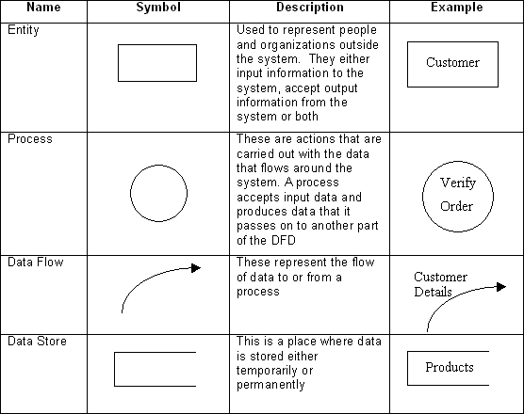Data flow diagrams are used by systems analysts to design information-processing systems but also as a way to model whole organizations. You build a DFD at the very beginning of your business process modeling in order to model the functions your system has to carry out and the interaction between those functions together with focusing on data exchanges between processes.You can associate data with conceptual, logical, and physical data models and object-oriented models.

**Fig 3.1 Data Flow Diagram Symbol**

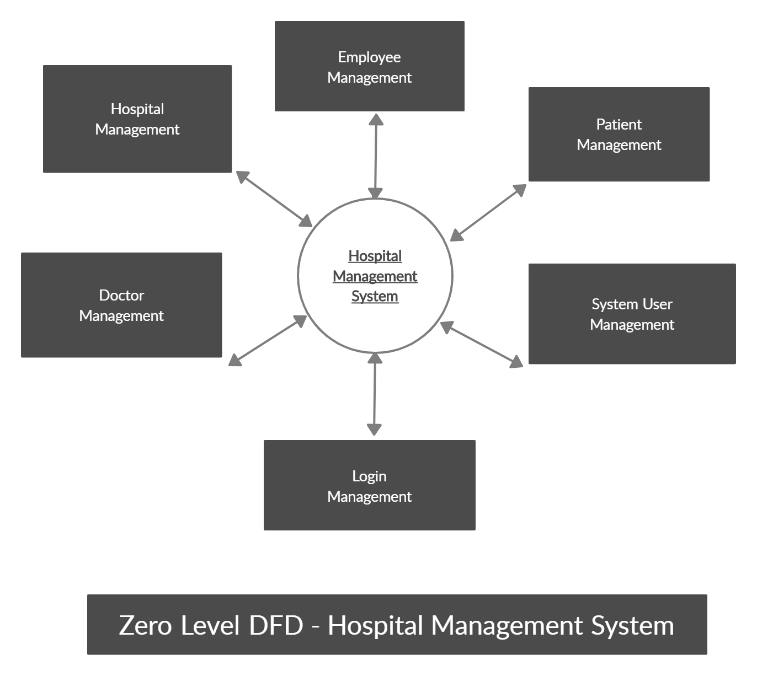

**Data Flow Diagram level - 0**

**Data Flow Diagram Level 1**

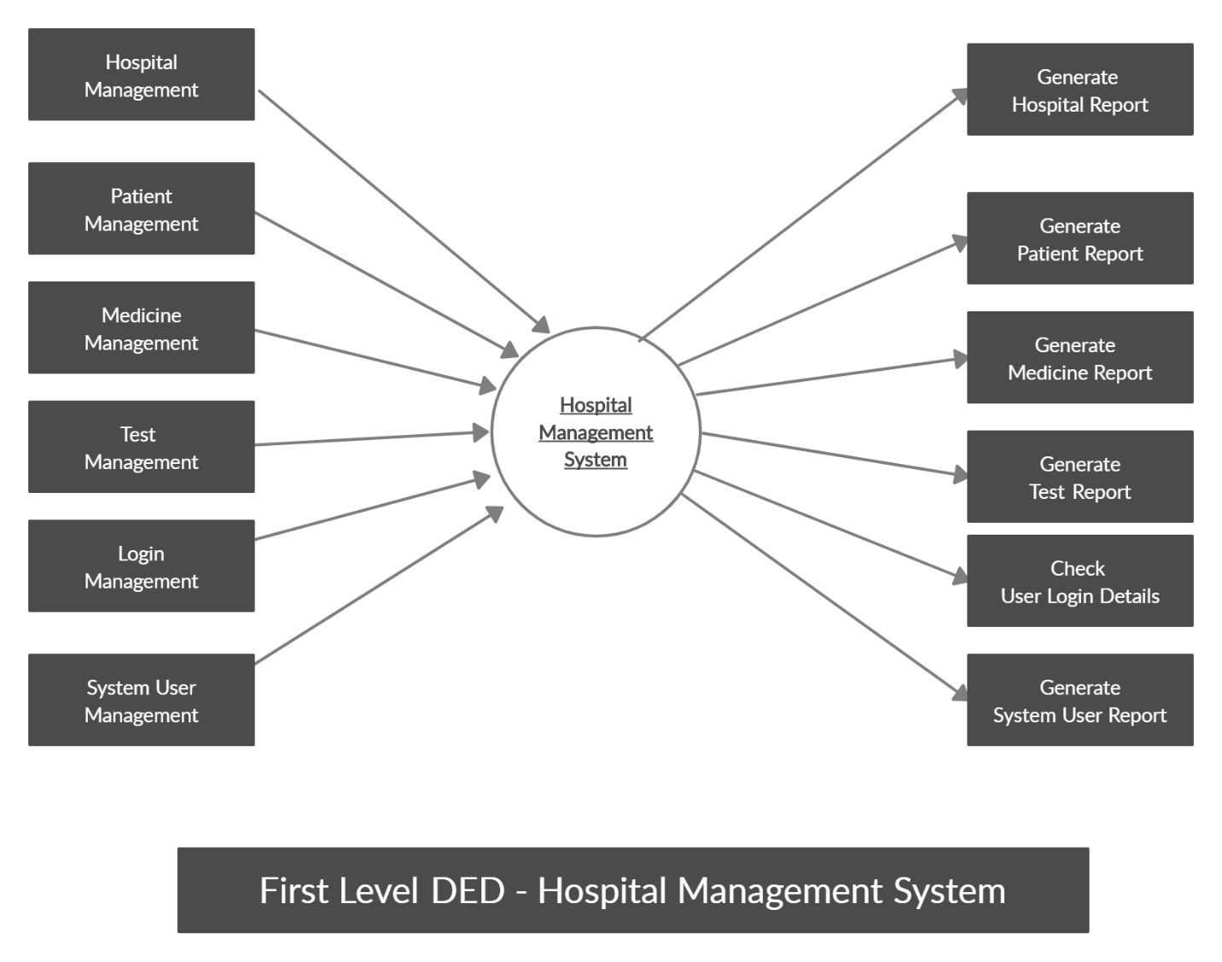

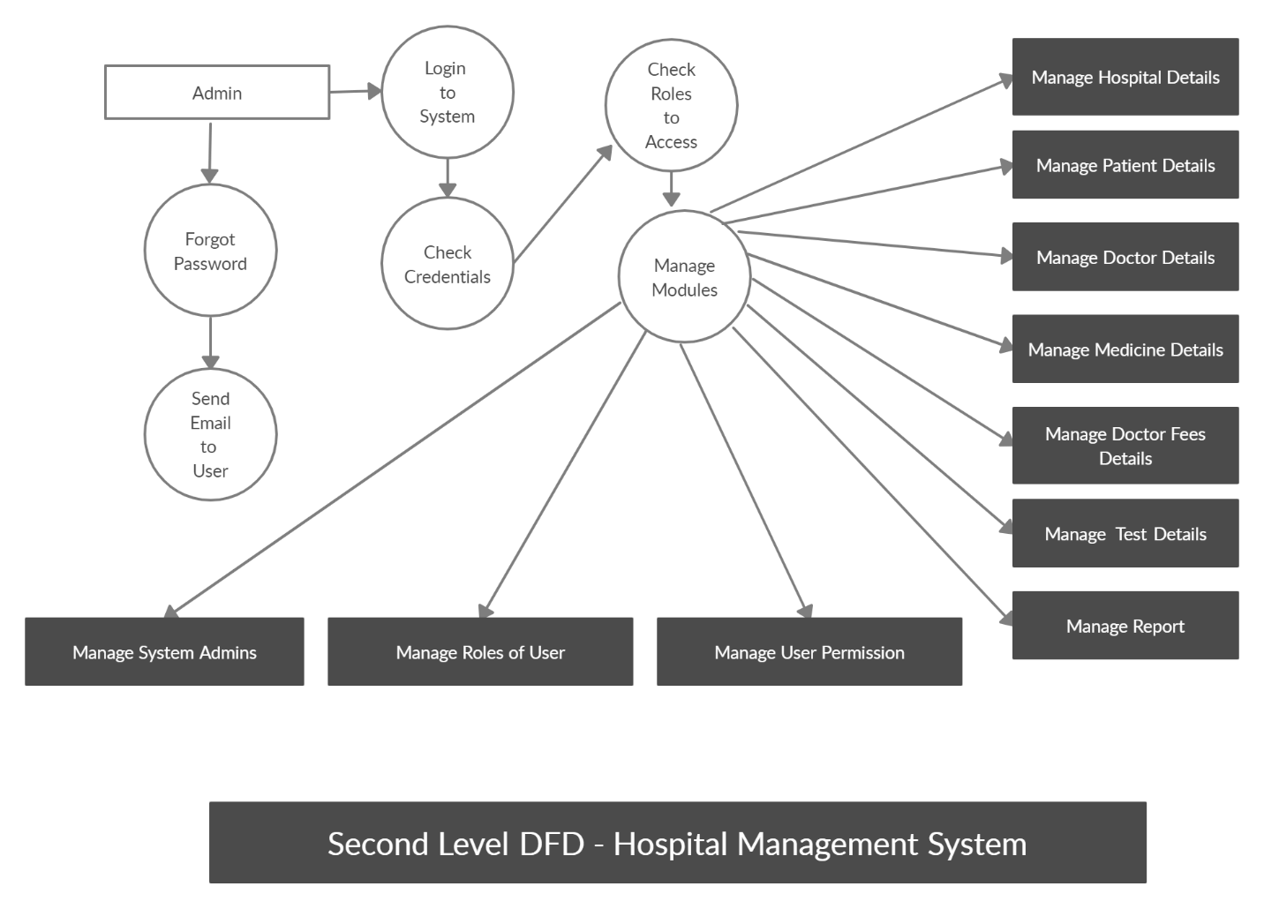

**Data Flow Diagram Level 2**

**3.3 Database Design**

A good database design is crucial for a high-performance application, just as an Aerodynamic body is important to a race car. If the car doesn’t have smooth lines, it will produce drag and go slower. Without optimized relationships, your database won’t perform as efficiently as possible. Thinking about relationships and database efficiency is part of normalization.

Beyond the issue of performance is the issue of maintenance—your database should be easy to maintain. This includes storing only a limited amount (if any) of repetitive data. If you have a lot of repetitive data and one instance of that data undergoes a change (such as a name change), that change has to be made for all occurrences of the data. To eliminate duplication and enhance your ability to maintain the data.

## Entity Relationship Diagram (ER-Diagram)

An entity-relationship diagram (ERD) is a graphical representation of an information system that shows the relationship between people, objects, places, concepts or events within that system. An ER Diagram [data modeling](http://searchdatamanagement.techtarget.com/definition/data-modeling) technique that can help define business processes and can be used as the foundation for a [relational database](http://searchsqlserver.techtarget.com/definition/relational-database).

While useful for organizing [data](http://searchdatamanagement.techtarget.com/definition/data) that can be represented by a relational structure, an entity-relationship diagram can't sufficiently represent semi-structured or [unstructured](http://searchbusinessanalytics.techtarget.com/definition/unstructured-data) [data,](http://searchbusinessanalytics.techtarget.com/definition/unstructured-data) and an ERD is unlikely to be helpful on its own in integrating data into a preexisting information system.

Three main components of an ERD are the [entities](http://whatis.techtarget.com/definition/entity), which are objects or concepts that can have data stored about them, the relationship between those entities, and the [cardinality,](http://whatis.techtarget.com/definition/cardinality) which defines that relationship in terms of numbers.

#### **Components of the ER Model**

The three main components of the ER Model are **entities**, **attributes** and **relationships:-**

* In ERM terms, an entity is a "thing" within the organization that we want to keep information about, such as a customer, employee or course. In other words, an entity in an ERM actually refers to a table, and rows within the table are referred to as entity occurrences. Entities are represented by rectangles containing the name of the entity. Entity names must be singular and in capital letters.
* Each entity has attributes which are the properties of each entity. Attributes will be implemented as columns in the tables. Each attribute has a domain which specifies these to possible values an attribute can have. For instance, the range of values for at telephone extension may be specific data set of integer numbers between 4000 and 4999. An attributes domain is not displayed in ER diagrams, but is recorded in the data dictionary.
* Attributes can be of various types. A composite attribute can be subdivided into smaller parts. For example, an attribute Name can be subdivided into First Name and Last Name. Attributes that cannot be subdivided are called simple attributes. First Name and Last Name are now simple attributes. Most attributes have only a single value and as such are called single valued attributes. For example, a Teacher can have only one Last Name or a Subject can have only one Subject Code. Multivalued attributes can have more than one value. For example, a Student could have more than one Certificate or a Department may have several Extensions.
* A key attribute is an attribute that has a unique value for each entity occurrence. In other words, a key attribute is used to identify each row uniquely. For example, a Subject Code will uniquely identify each subject as not subjects can have the same Subject Code. Key attributes are represented by underlining its name.
* A relationship is the association between entities or entity occurrences.

#### **3.3.1 ER Diagram:**

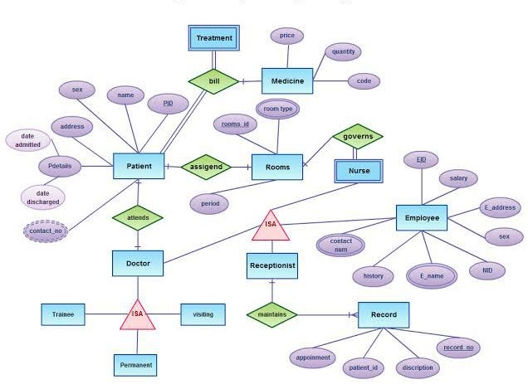

**Chapter 4 SOFTWARE TESTING**

## 4.1 Testing

* + - Software testing is the process of executing a program with intension of finding errors in the code. It is a process of evolution of system or its parts by manual or automatic means to verify that it is satisfying specified or requirements or not.
    - Generally, no system is perfect due to communication problems between user and developer, time constraints, or conceptual mistakes by developer.
    - To purpose of system testing is to check and find out these errors or faults as early as possible so losses due to it can be saved.
    - Testing is the fundamental process of software success.
    - Testing is not a distinct phase in system development life cycle but should be applicable throughout all phases i.e. design development and maintenance phase.
    - Testing is used to show incorrectness and considered to success when an error is detected.

## Objectives of Software Testing

* + - **Software Quality Improvement:** The computer and the software are mainly used for complex and critical applications and a bug or fault in software causes severe losses. So a great consideration is required for checking for quality of software.

#### **Verification and Validation:**

* + Verification means to test that we are building the product in right way .i.e. are we using the correct procedure for the development of software so that it can meet the user requirements.
  + Validation means to check whether we are building the right product or not.
    - **Software Reliability Estimation:** The objective is to discover the residual designing errors before delivery to the customer. The failure data during process are taken down in order to estimate the software reliability.

## Principles of Software Testing

* + 1. All tests should be traceable to end user requirements.
    2. Tests should be planned long before testing begins.
    3. Testing should begin on a small scale and progress towards testing in large.
    4. To be most effective testing should be conducted by an independent third party.

The primary objective for test case design is to derive a set of tests that has the highest livelihood for uncovering defects in software. To accomplish this objective two different categories of test case design techniques are used. They are

* + 1. White box testing.
    2. Black box testing.

#### **White-box testing:**

White box testing focus on the program control structure. Test cases are derived to ensure that all statements in the program have been executed at least once during testing and that all logical conditions have been executed.

* **Block-box testing:**

Black box testing is designed to validate functional requirements without regard to the internal workings of a program. Black box testing mainly focuses on the information domain of the software, deriving test cases by partitioning input and output in a manner that provides through test coverage. Incorrect and missing functions, interface errors, errors in data structures, error in functional logic are the errors falling in this category.

## Testing fundamentals

Testing is a process of executing program with the intent of finding error. A good test case is one that has high probability of finding an undiscovered error. If testing is conducted successfully it uncovers the errors in the software. Testing cannot show the absence of defects, it can only show that software defects present.

## Testing Information flow

Information flow for testing flows the pattern. Two class of input provided to test the process. The software configuration includes a software requirements specification, a design specification and source code.

Test configuration includes test plan and test cases and test tools. Tests are conducted and all there are evaluated. That is test results are compared with expected results. When erroneous data are uncovered, an error is implied and debugging commences.

Chapter 5 **Implementation and User Interface**

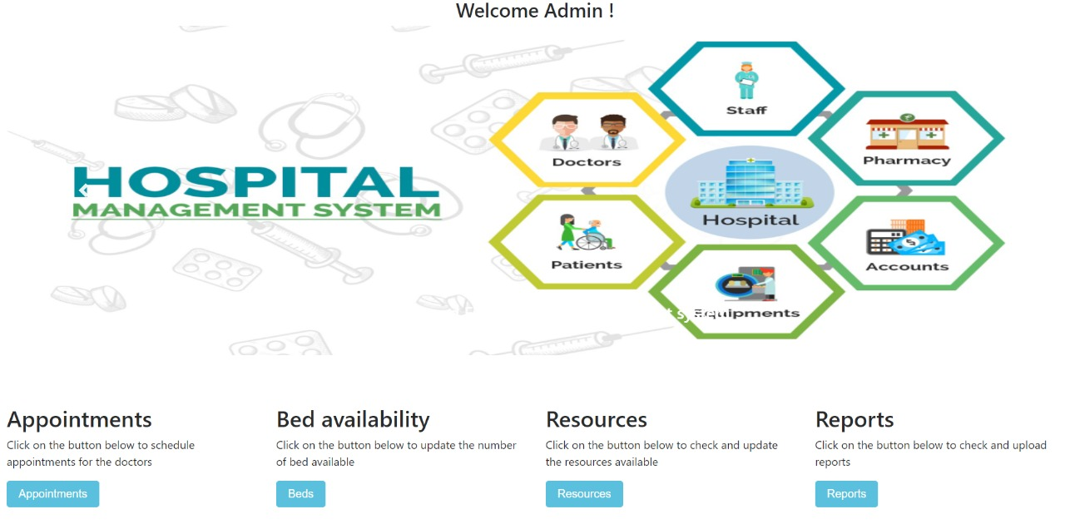 Fig no. 1

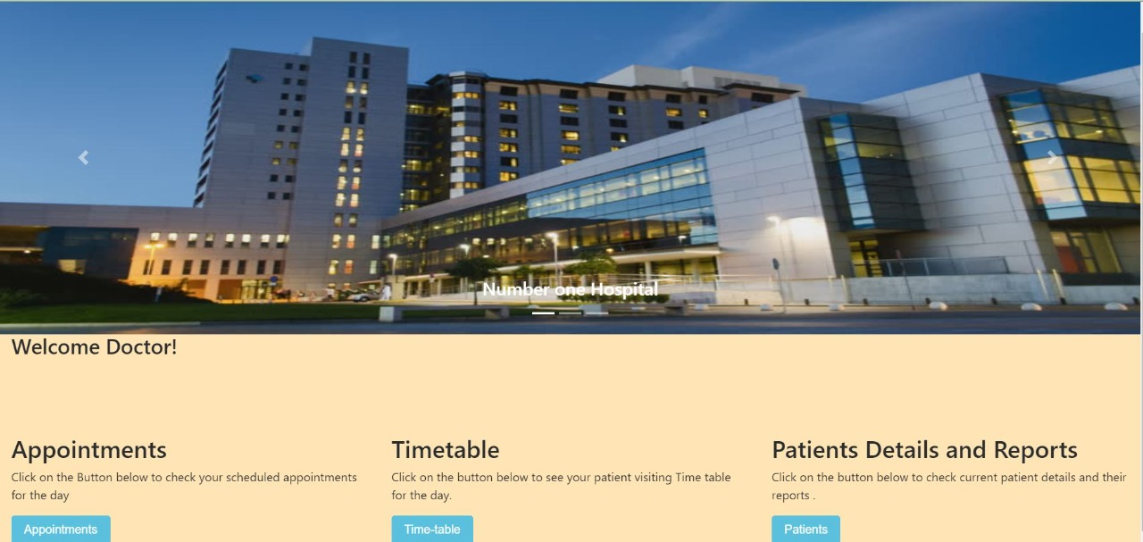

Fig no. 2

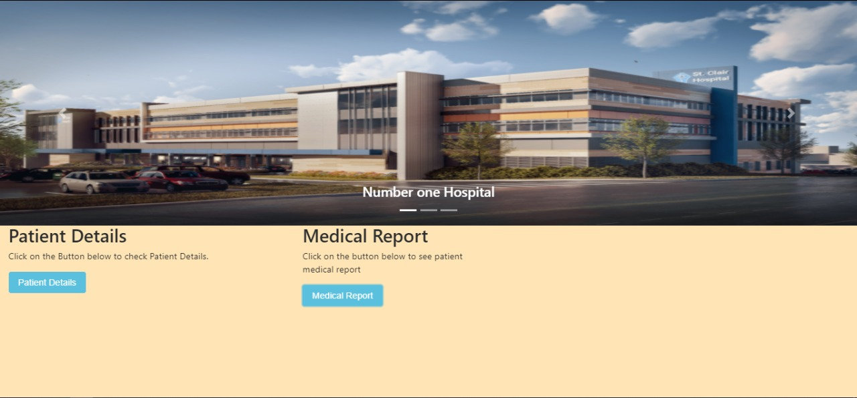

Fig no. 3

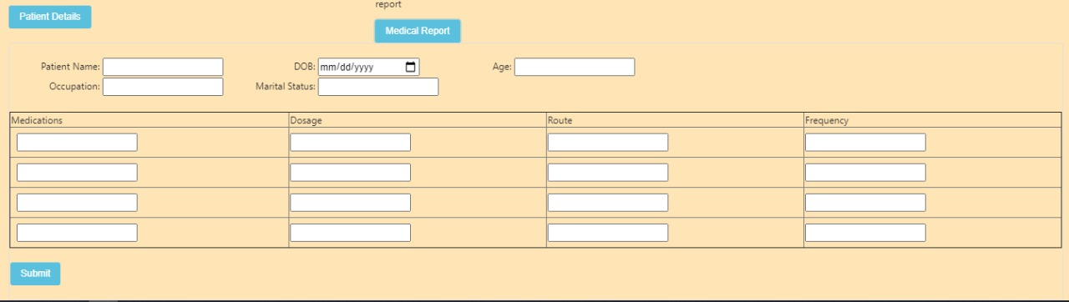

Fig no. 4

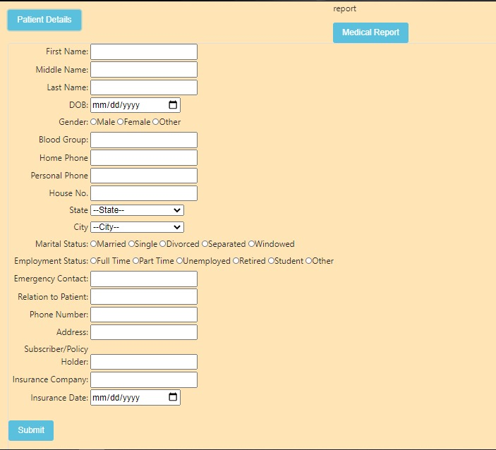

Fig no. 5

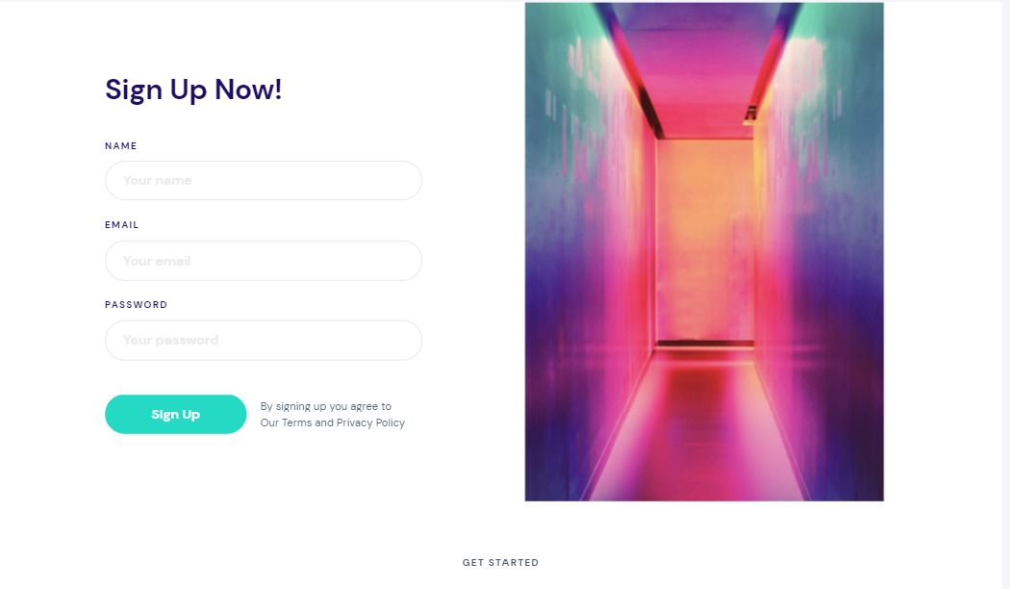

Fig no. 6

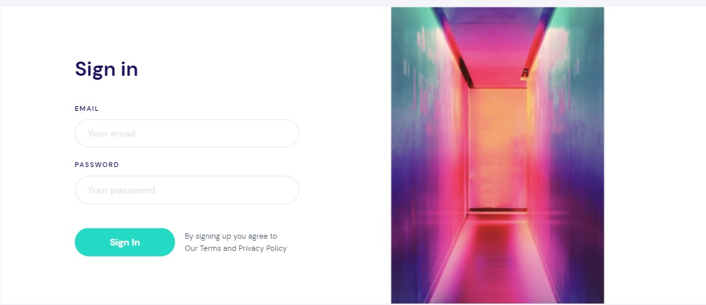

Fig no. 7

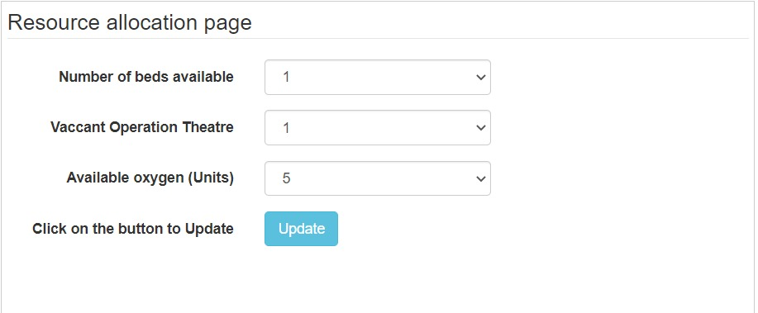

Fig no. 8

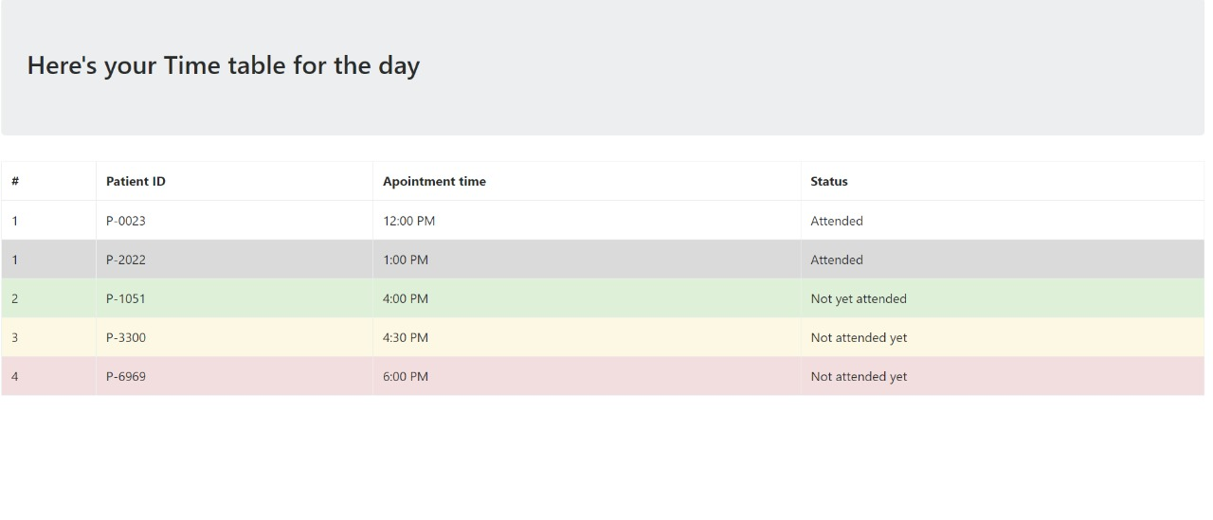 Fig no. 9

Chapter 6 **CONCLUSION**

This was the first considerably large and important project undertaken by our team during our BCA course. It is an experience that changed the way we perceived project development. The coding could not be started before the whole system was completely finalized. Even then there were so many changes required and the coding needed to be changed. We all attribute this to inadequate information gathering. Though there were many meetings with the team and most of the requirements were gathered, a few misinterpretations of the requirements still crept in. It made us realize how important the systems analysis phase is. The project is a classic example, that learning of concepts needs to be supplemented with application of that knowledge.

On the whole, it was a wonderful experience developing **Hygeia E-HealthCare System** and we would have considered our education incomplete without undertaking such a project which allowed us to apply all that we have learnt and tried to develop a project that can be useful for people by saving their time. It is developed using HTML and PHP so that it can be accessed very easily and at any time the system is developed with an aim of usability so that it becomes an easy-to-use system that requires the least amount of user input possible. For using this system general computer knowledge is enough. It is an easy well-structured module that will show user most adequate website to buy his product from. Users will be authenticated to ensure that no unauthorized users gain access to private information

Chapter 7 **BIBLIOGRAPHY** **&REFERENCES**

To develop this project (Hygeia E-HealthCare System), we used HTML, CSS JavaScript and Bootstrap for Front End and SQL Server 2018, XAMPP, PHP for Back End (Database). We take some knowledge towards automation system from some books that are given below:

• *The* *Joy* *of* *PHP* *Programming:* *A* *Beginner’s* *Guide* *–* *by* *Alan* *Forbes*

• *PHP* *&* *MySQL* *Novice* *to* *Ninja* *–* *by* *Kevin* *Yank*

**References:**

[[1]. www.w3schools.com/php.net](http://www.w3schools.com/php.net)

[[2]. www.stackoverflow.com](http://www.stackoverflow.com/)

[[3]. www.php.net-tutorial.com](http://www.php.net-tutorial.com/)

[4]. www.w3schools.com/css](http://www.w3schools.com/css)